Report
on

Integration of PROM framework with SonarQube and Atlassian Jira Agile

submitted to
Prof. Alberto Sillitti
Center for Applied Software Engineering (CASE)
December 2, 2014

by
Peter Moser

This document investigates on what PROM could add to SonarQube and Atlassian Jira. First, I start from what SonarQube already supports. Second, I describe what PROM can add to their functionalities, that is, what are possible features of PROM that could improve their economic value. Afterward, I repeat both steps for Atlassian Jira, especially for Jira Agile. Please notice, that I write this report in a non-official manner, such that I can seed random thoughts on how we could integrate PROM in both third-party tools.

Table of contents
SonarQube 1
What does SonarQube provide? 1
What can PROM get from SonarQube or add to it? 4
Suggestions for plugins 4
1st plugin: Combine effort data with source code 4
2nd plugin: Combine effort data with tasks and issues 5
3rd plugin: Integrate PROM's GQ(I)M dashboard 5
Table of figures
Fig. 1: Code duplications per line, block, and file. 2
Fig. 2: Technical debt and complexity metrics over time 2
Fig. 3: Unit test coverage, success rates and exection time 2
Fig. 4: Metrics about documentation 3
Fig. 5: LOC compared to SQALE Ratings 3
Fig. 6: LOC metric in SonarQube for various languages 4

SonarQube

What does SonarQube provide?
SonarQube offers product metrics for various languages: ABAP, Android, C/C++, C-Sharp (C#), COBOL, Flex, Groovy, Java, JavaScript, Objective-C, PHP, PL/I, PL/SQL, Python, RPG, VB.NET, Visual Basic 6, Web (HTML, JSP/JSF), and XML. In addition to build-in functionalities, plugins allow for multi-language analysis of code quality. It is even possible to compare metrics between different languages and projects, i.e. side by side comparison between Java and C++.
These are the product metrics currently supported by SonarQube (formerly known as Sonar):
- Cyclomatic Complexity: overall, and average by class, file and function.
- Design issues:
  - Package cycles, File cycles, File dependencies, and package edge weight, that is, number of dependencies between packages
  - Depth of inheritance tree (tic)
  - Number of children (noc) of a class
  - Response for class (rfc)
  - Afferent and efferent couplings (ca, ce): how many classes use this class, or how many classes are used by this class
  - Lack of cohesion of methods (lcom4), i.e. set of related components of a class. There should be only one, otherwise the class should be divided into smaller classes.
- Duplications of source code blocks and lines.
- Metrics about issues: open, confirmed, closed, false positive.
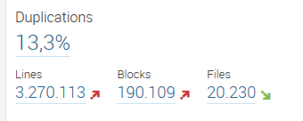Fig. 1: Code duplications per line, block, and file.
- Metrics about defined rule compliance, i.e. violation density.
- Rules compliance index (RCI) =
  - 100 - (Weighted issues / Lines of code * 100)
Violations is the number of rule violations automatically calculated by analyzing the source code of a project. Different projects can be compared to each other. In addition, developers can weight violations to find out where they must start fixing problems first.
- Technical debt is the effort to fix all issues in minutes.
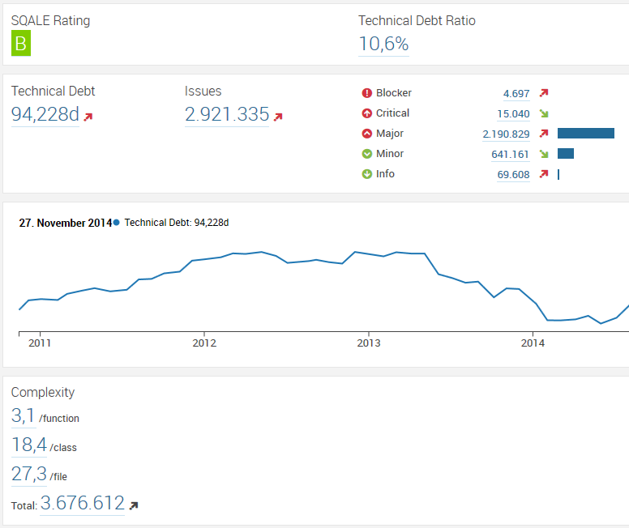Fig. 2: Technical debt and complexity metrics over time
- Severity of issues is calculated automatically through defined rules, several rule packages already exist for different languages, and are bundled together with the default installation.
- Size metrics: LLOC, LOC, generated LOC, method counts, class counts, file counts, public API, and statements.
- Test metrics: condition coverage for branching code, and separately for new code, and line coverage. Further more it exists a unit test integration with duration, errors, failures, and success density.
- Documentation metrics: lines of comments, significant lines of comments, commented out production code, and Javadoc support.
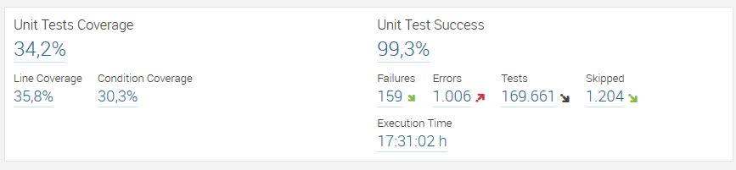Fig. 3: Unit test coverage, success rates and exection time
- Source code repository metrics about commits, revisions, and authors' performance.
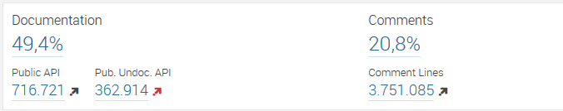Fig. 4: Metrics about documentation
According to [] the most important metrics are: duplicated blocks, violations, public undocumented APIs, uncovered complexity by tests, function and class complexity distribution, and package edge weights.
The overall measures of these metrics are used to calculate the technical debt in man days:
- Technical Debt in man days = technical_debt =
- cost_to_fix_duplications +
- cost_to_fix_violations +
- cost_to_comment_public_API +
- cost_to_fix_uncovered_complexity +
- cost_to_bring_complexity_below_threshold +
- cost_to_cut_cycles_at_package_level
This technique is known as SQALE Rating. Technical debt ratio, that is shown in figure 2 and figure 5, is calculated with the following formula:
- Technical Debt Ratio = technical_debt / estimated_development_cost
In addition to these metrics, SonarQube provides Eclipse and IntelliJ plugins to handle issues directly from within the IDEs. It also harvests some state of the art issue tracker currently available on the market, i.e. JIRA issues, Trac, Mantis Bug Tracker. There exist also plugins to seamlessly include other test and metric environments, like the Apache JMeter plugin to test performance of static and dynamic resources, or Pitest to handle mutation testing.
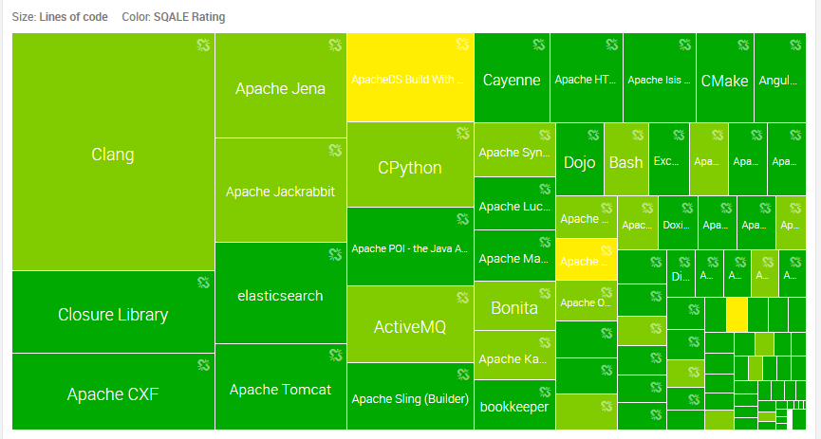Fig. 5: LOC compared to SQALE Ratings

What can PROM get from SonarQube or add to it?
As what I have seen so far, SonarQube is mainly focused on product metrics and issue tracking environments, i.e. bug reports and task lists. However, I think it has no effort collection system, since these information is always given manually by developers. They insert estimates and progressions by hand into software development management tools, that are harvested later by the SonarQube analyzing tools, like SonarQube Runner, SonarQube Ant Task, Maven or Gradle Engines.
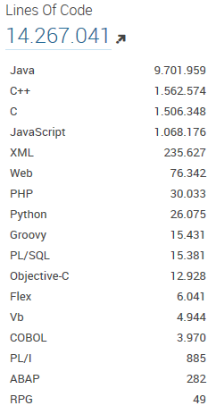Fig. 6: LOC metric in SonarQube for various languages
I put the focus to the SonarQube Runner tool for the moment, since it is the recommended analyzer. This tool analyzes a project and puts all calculated metrics into a specified database.
First, we could use this data to enhance PROM's feature list, with the metrics mentioned earlier in this document.
Second, PROM could add real-time effort data to imported task structures and issues. That is, combine effort accumulated by a developer per task. These tasks could then, also with PROM, be combined with source code fragments, i.e. classes, methods, namespaces, and projects. The capability of SonarQube to provide a list with the most critical project components, that is components that have a high probability to fail, combined with real effort data connected to them, could provide powerful statistics. For example, if a developer estimated a task with X man days and worked on it for a certain time Y, an effort analysis plugin that accesses PROM data, could provide real-time “technical debt” or “sprint completion” (i.e., for SCRUM methodology) statistics. On one hand, we could provide such statistics for tasks and issues. On the other hand, we could provide them for source code fragments.
Another feature, that we could use to extend PROM, are source code complexity metrics. The PROM team implemented some metrics for source code analysis. These are, CBO (coupling between objects), CC (cyclomatic complexity), DIT (Depth of Inheritance Tree), LCOM (lack of cohesion of methods), NOC (number of children), RFC (response set of a class), and WMC (weighted methods for class), and more direct metrics like LOC, and LLOC. However, these metrics work only (as I know) for Java and C++. SonarQube provides most of these metrics for a broad variety of languages, as you can see in figure 6.

Suggestions for plugins

1st plugin: Combine effort data with source code
First, I would suggest to integrate non-invasive effort metrics to projects that SonarQube manages. That is, map effort to source code fragments.
A possible outcome could be a table that shows the overall effort of a project, and on higher granularity it provides effort subdivided into namespaces, classes, and methods. Since SonarQube allows to import source code from revision control systems, like GIT or SVN, it would be important to add revisions to such metrics as well. This is, as I know, not implemented yet for PROM.

2nd plugin: Combine effort data with tasks and issues
Second, I would suggest to create a visualization plugin that shows non-invasive effort metrics per task and issue. We could also add PERT or GANTT to gain additional value. To provide a professional state-of-the-art tool, that supports third-party products we could also create an export function, i.e. for Microsoft Project. However, SonarQube is an open-source tool, I think it would be better to export data to other open-source management tools, like GanttProject. I have done such a project for my Bachelor thesis. It is possible to reuse this as a SonarQube plugin.

3rd plugin: Integrate PROM's GQ(I)M dashboard
Third, SonarQube has no support for a GQM dashboard. I think, developers will appreciate if we create a SonarQube GQ(I)M dashboard to visualize their statistics enriched with our effort metrics.
All three plugins could be combined to a PROM suite for SonarQube. In general, we should provide some REST interface, to simply query PROM's effort collections according to certain filters and constraints. However, this would involve some major project changes and improvements.

Atlassian Jira Agile

What does Jira Agile provide?
Jira Agile provides task management support for the two main agile methodologies SCRUM and Kanban. It focuses on creating and managing tasks, issues, stories, epics and bug reports. Developers can estimate and prioritize these planning cards. Administrators define task flow processes according to certain filters and constraints. All developers must follow these rules afterward. The whole Jira framework is highly adaptable and configurable to future needs, i.e. new Kanban board columns and statuses can be defined and multiple projects can be visualized all at once on a configurable dashboard. It also integrates with Jira, Confluence and other development tools.
Another feature is the integration with source code revision tools, like Git, SVN and Bitbucket. It bridges the gap between user stories and source code commits.
On the side of analysis, Jira Agile does not offer a lot. At least build-in features are scarce. If developers use Kanban, they can monitor current trends and analyze past progresses. The tool that visualizes this metrics is called cumulative flow diagram, please refer to figure 7. I think, this could be a good point where PROM comes in with analysis tools. Maybe we could add effort metrics and product metrics here. For instance, CC, LLOC, and LCOM4. It could be even feasible to integrate SonarQube features here, maybe we could add them first to PROM services, or provide an unified interface to PROM and SonarQube metrics and statistics through a REST service or something similar.
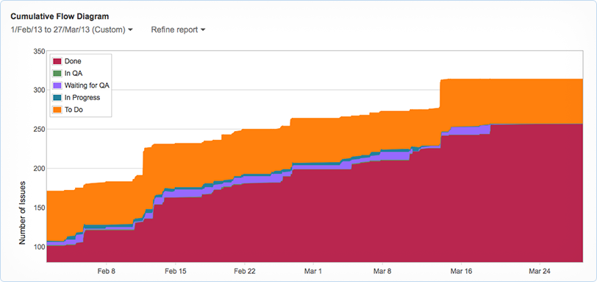Fig. 7: Cumulative flow diagram with number of issues over time

http://www.sonarqube.org/at-long-last-sonarqube-is-a-true-polyglot/
http://docs.codehaus.org/display/SONAR/Metric+definitions
Keheliya Gallaba , Software Engineer at WSO2, and author of http://de.slideshare.net/keheliya/sonar-metrics
http://docs.codehaus.org/display/SONAR/Technical+Debt#TechnicalDebt-ComparingprojectswiththeTechnicalDebtRatioandtheSQALERating
MantisBT is an open source issue tracker: http://www.mantisbt.org/
http://docs.codehaus.org/display/SONAR/JMeter+Plugin
PIT is a mutation testing tool for java: http://pitest.org/
How Sonar analyzes source code: http://docs.codehaus.org/display/SONAR/Analyzing+Source+Code

